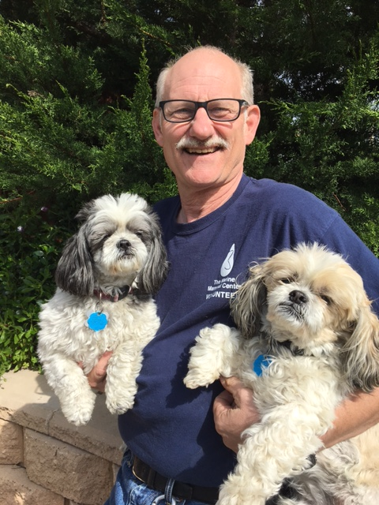
Ted Key

Education:
Bachelor of Fine Arts and Post Baccalaureate Certification in Education K-12 with Honors from The University of Wisconsin-Milwaukee

Employment:
During my college years I built large induction heat treating and melting power supplies, working 30 hours a week while carrying a full course load – I can’t imagine doing that today! I moved to Arizona to teach at a boarding school for three years, then relocated to San Jose to manage a programming and tech support group, first for the manufacturer of grocery store energy management equipment and then for Safeway Stores Inc. in Oakland. We were responsible for 24/7/365 monitoring of refrigeration and environmental systems in 650 stores nationwide. I returned to teaching for another 25 years at Notre Dame High School in San Jose, a women’s Catholic college prep high school. I built a Visual Arts department, specializing in photography and ceramics. Teaching these talented and bright young women leaders of tomorrow was a privilege.

Cambria Life:
Since settling here six years ago, my wife and I have completely remodeled our home and removed it from the rental market. Rebecca and I attend the UUCC and run their Adopt-a-Highway section on Hwy 46; cleaning up the highway offers a real sense of satisfaction. My wife is a hand bell performer, a member of the University Women of Cambria, and sings with Lyra, a women’s vocal group. We both sing in the Cambria Chorale and have performed in the last two Lions Follies, building local scholarship funding.

We also volunteer for the Marine Mammal Center in Morro Bay where I rescue and transport sea lions, elephant seals, and otters. Recently, I’ve re-designed our capture/transport carriers, which has gained attention by State Fish and Game operations. We hope to have them manufactured to assist a variety of wildlife programs.

Most days you can find me walking down Windsor with my Shih Tzu so please don’t hesitate to stop and chat.

